Journal of Material Science & Nanotechnology

About the Journal:
The Journal of Materials Science & Nanotechnology is an international, peer-reviewed, open-access journal dedicated to publishing high-quality research that advances the science and engineering of materials across fundamental and applied disciplines. The journal provides a global platform for researchers, academicians, engineers, and industry professionals to disseminate innovative findings on the design, synthesis, characterization, processing, and application of advanced materials and nanotechnologies. It aims to foster interdisciplinary collaboration and promote scientific excellence by publishing original research articles, reviews, short communications, and case studies that contribute to the advancement of materials science and nanotechnology.
The journal covers a broad range of topics, including advanced nanomaterials, biomaterials, polymers, ceramics, composites, metals and alloys, smart and functional materials, graphene and carbon nanostructures, thin films and coatings, nanoelectronics, optoelectronic materials, biosensors, metamaterials, computational materials science, additive manufacturing, corrosion engineering, and emerging nanotechnologies. By highlighting cutting-edge discoveries and technological innovations, the Journal of Materials Science & Nanotechnology supports the development of sustainable materials and next-generation technologies that address global challenges in healthcare, energy, electronics, environmental protection, aerospace, and advanced manufacturing.

Latest News:
AI-Powered Autonomous Laboratory Discovers New Lead-Free Nanomaterials:-
Scientists developed an autonomous AI-driven laboratory capable of exploring billions of synthesis possibilities and identifying bright, lead-free light-emitting nanomaterials in only 12 hours. The breakthrough could accelerate the development of environmentally friendly LEDs, photodetectors, solar energy devices, and other optoelectronic technologies while dramatically reducing the time needed for materials discovery.


MIT Solves a Long-Standing Materials Science Mystery:-
Researchers at the Massachusetts Institute of Technology uncovered the hidden atomic structure of a long-studied material, resolving a decades-old scientific puzzle. The discovery provides new insights into how atomic arrangements influence electrical and magnetic properties, opening opportunities for next-generation electronics, quantum devices, and advanced functional materials.


AI Accelerates Discovery of New Molecules for Environmental Applications:-
AI startup CuspAI announced major progress in using generative AI to design entirely new molecules and materials for climate challenges, including the removal of PFAS ("forever chemicals") from water and improved carbon capture technologies. By combining AI, simulations, and laboratory validation, the platform aims to reduce the time required to discover advanced materials from years to months.


Graphene-Enhanced Concrete Gains Momentum in Sustainable Construction:-
Graphene-enhanced concrete is gaining commercial traction in 2026 as construction companies increasingly adopt it for sustainable infrastructure projects. By incorporating graphene into cement mixtures, engineers have demonstrated improved compressive strength, enhanced durability, reduced cracking, and lower cement consumption, helping to reduce the carbon footprint of buildings and transportation infrastructure. The growing commercialization of graphene-based construction materials highlights the expanding role of nanotechnology in civil engineering and sustainable development.

Programmable & Reconfigurable Metamaterials
Researchers are developing metamaterials that can dynamically change their shape or electromagnetic response in real time for applications in 6G communications, smart antennas, and adaptive optics.
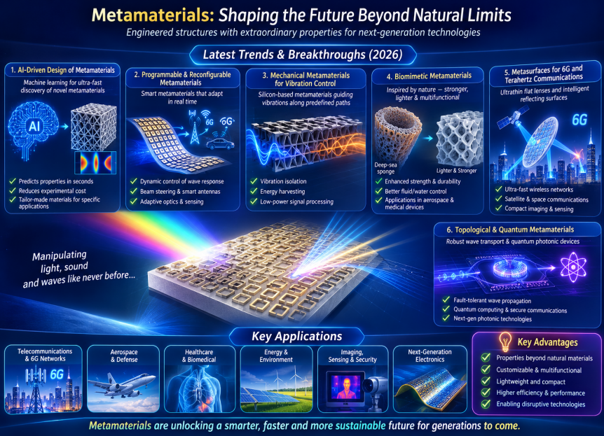

Scientific Topics:

- Materials Science and Engineering
It focuses on the study, design, and development of materials such as metals, polymers, ceramics, semiconductors, and composites. It explores the relationship between a material's structure, properties, processing, and performance to create innovative solutions. The field drives advancements in industries including healthcare, energy, aerospace, electronics, and manufacturing.
- Advanced Nanomaterials
It involve the design and application of materials with structures at the nanoscale (1–100 nm), offering unique physical, chemical, and biological properties. They are widely used in drug delivery, energy storage, electronics, environmental remediation, and advanced coatings. These materials enable the development of high-performance technologies with improved efficiency, durability, and functionality.
- Biomaterials and Medical Devices
Biomaterials and Medical Devices focus on developing materials and technologies that interact safely with biological systems to diagnose, treat, or replace damaged tissues and organs. Biomaterials such as polymers, ceramics, metals, and composites are widely used in implants, prosthetics, drug delivery systems, and tissue engineering. These innovations enhance patient care by improving treatment outcomes, functionality, and quality of life.
- Carbon Nanostructures and Graphene
Carbon Nanostructures and Graphene explore advanced carbon-based materials with exceptional mechanical, electrical, thermal, and chemical properties. These materials, including graphene, carbon nanotubes, and fullerenes, are widely applied in electronics, energy storage, sensors, composites, and biomedical technologies. Their unique characteristics enable the development of next-generation high-performance and sustainable applications.
- Mining and Metallurgy
Mining and Metallurgy focus on the extraction, processing, and refinement of minerals and metals for industrial applications. The field encompasses mineral exploration, ore beneficiation, metal extraction, alloy development, and sustainable resource management. Advances in mining and metallurgy support efficient production, improved material performance, and environmentally responsible practices.
6. Emerging Areas of Materials Science
It explore innovative materials and technologies that address future challenges in healthcare, energy, electronics, sustainability, and advanced manufacturing. Research focuses on smart materials, quantum materials, bio-inspired materials, and multifunctional nanomaterials with enhanced performance. These advancements are driving breakthroughs across scientific research and industrial applications.
7. Nanoengineering and its Applications
Involve the design, fabrication, and manipulation of materials and devices at the nanoscale to achieve enhanced performance and functionality. It integrates principles of engineering, physics, chemistry, and biology to develop innovative solutions for healthcare, electronics, energy, and environmental applications. Nanoengineering is driving next-generation technologies with improved efficiency, precision, and sustainability.
8. Polymer Science & Nano Engineering
Polymer Science & Nano Engineering focuses on the design, synthesis, and characterization of advanced polymeric materials enhanced through nanotechnology. The integration of nanomaterials with polymers improves mechanical strength, thermal stability, electrical conductivity, and biocompatibility. These materials have wide-ranging applications in healthcare, electronics, packaging, energy, and sustainable manufacturing.
9.Computational Modeling of Metals & Materials
Computational Modeling of Metals & Materials involves the use of advanced simulation and computational techniques to predict the structure, properties, and performance of metals and materials. It enables researchers to optimize material design, processing, and behavior while reducing experimental costs and development time. These approaches accelerate innovations in aerospace, automotive, energy, electronics, and advanced manufacturing.
10. 3D Printing and Additive Manufacturing
It involves in the layer-by-layer fabrication of components directly from digital designs, enabling rapid prototyping and complex geometries. These technologies reduce material waste, shorten production times, and support the customization of products across various industries. Their applications span healthcare, aerospace, automotive, construction, and advanced manufacturing.
11. Metamaterials
Metamaterials are artificially engineered materials designed to exhibit unique electromagnetic, optical, acoustic, or mechanical properties not found in naturally occurring materials. Their precisely structured architectures enable advanced functionalities such as negative refraction, cloaking, superlensing, and wave manipulation. Metamaterials are transforming applications in telecommunications, sensing, imaging, aerospace, and next-generation photonic devices.

Editorial in Chief:
Lia Krusin-Elbaum
The City College of New York, United States
Biography:
Lia Krusin-Elbaum has been a Professor of Physics at The City College of New York since 2010. Her Ph.D. degree is in Condensed Matter Physics (NYU, 1979) and she was a scientist at the IBM's T.J. Watson Research Center, NY (1979-2010). Dr. Krusin-Elbaum is a recipient of ten IBM Invention Achievement Awards and holds over 27 US patents. She is a Fellow of the American Physical Society (1993-) and was elected (2022) to serve on the USDOE Basic Energy Sciences Advisory Committee. She is a co-lead of the Columbia U. NSF-MRSEC PAQM (2020-) and of the NSF-CREST IDEALS Centers (2015-).
7 Articles are attached herewith….

